# Assignment-2

|  |  |
| --- | --- |
| Assignment Date | 02 October 2022 |
| Student Name | Yokeshraj A |
| Student Roll Number | 2127190501149 |
| Maximum Marks | 2 Marks |

**Question-1:**

1. Create a FlaskApp
2. Add the Home page, AboutPage
3. Add theBootstrap
4. Add the Sign in page and App the SignupPage

|  |  |
| --- | --- |
| **Solution:** |  |
| **app.py:** | fromflaskimport Flask,render_template,request,url_for,redirect,flashfrommarkupsafeimportescape  app=Flask(name__) @app.route("/")  defindex():  returnrender_template("home.html")  @app.route("/home.html") defhello():  returnrender_template("home.html")  @app.route("/about.html") defprofile():  returnrender_template("about.html")  @app.route("/signup.html") defsignup():  returnrender_template("signup.html")  @app.route("/signin.html") defsignin(): |

returnrender_template("signin.html")

@app.errorhandler(404)

defpage_not_found(error):

returnrender_template('page_not_found.html'),404

# Templates: Homepage

{%extends'base.html'%}

{%blockhead%}

<title>homepage</title>

{%endblock%}

{%blockbody%}

<mainclass="px-3">

<h1>Coveryourpage.</h1>

<pclass="lead">hiyoucansigninhere</p>

<pclass="lead">

<ahref="signup.html"class="btnbtn-success">Signup</a>

</p>

</main>

{%endblock%}

**Basepage**

<!DOCTYPEhtml>

<htmllang="en">

<head>

<metacharset="utf-8">

<metaname="viewport"content="width=device-width,initial- scale=1">

<link href="[https://cdn.jsdelivr.net/npm/bootstrap@5.0.2/dist/css/bootstrap.min.](https://cdn.jsdelivr.net/npm/bootstrap%405.0.2/dist/css/bootstrap.min)css"rel="stylesheet"integrity="sha384- EVSTQN3/azprG1Anm3QDgpJLIm9Nao0Yz1ztcQTwFspd3yD65VohhpuuCOmLASjC" crossorigin="anonymous">

<script src="[https://cdn.jsdelivr.net/npm/bootstrap@5.0.2/dist/js/bootstrap.bundle](https://cdn.jsdelivr.net/npm/bootstrap%405.0.2/dist/js/bootstrap.bundle)

.min.js"integrity="sha384- MrcW6ZMFYlzcLA8Nl+NtUVF0sA7MsXsP1UyJoMp4YLEuNSfAP+JcXn/tWtIaxVXM" crossorigin="anonymous"></script>

<!--<linkrel="stylesheet"href="{{url_for('static', filename='css/style.css')}}">-->

{%blockhead%}{%endblock%}

</head>

<body>

<navclass="navbarnavbar-expand-lgnavbar-lightbg-light">

<divclass="container-fluid">

<aclass="navbar-brand"href="#">Navbar</a>

<buttonclass="navbar-toggler"type="button"data-bs- toggle="collapse"data-bs-target="#navbarSupportedContent"aria- controls="navbarSupportedContent"aria-expanded="false"aria-label="Toggle navigation">

<spanclass="navbar-toggler-icon"></span>

</button>

<divclass="collapsenavbar-collapse" id="navbarSupportedContent">

<ulclass="navbar-navme-automb-2mb-lg-0">

<liclass="nav-item">

<aclass="nav-linkactive"aria-current="page" href="home.html">Home</a>

</li>

<liclass="nav-item">

<aclass="nav-link"href="signin.html">signin</a>

</li>

<liclass="nav-item">

<aclass="nav-link"href="signup.html">signup</a>

</li>

<liclass="nav-item">

<aclass="nav-link"href="about.html">about</a>

</li>

<liclass="nav-itemdropdown">

<aclass="nav-linkdropdown-toggle"href="#" id="navbarDropdown"role="button"data-bs-toggle="dropdown"aria- expanded="false">

Dropdown

</a>

<ulclass="dropdown-menu"aria- labelledby="navbarDropdown">

<li><aclass="dropdown-item"href="#">Action</a></li>

<li><aclass="dropdown-item"href="#">Another

action</a></li>

here</a></li>

<li><hrclass="dropdown-divider"></li>

<li><aclass="dropdown-item"href="#">Somethingelse

</ul>

</li>

</ul>

<formclass="d-flex">

<inputclass="form-controlme-2"type="search" placeholder="Search"aria-label="Search">

<buttonclass="btnbtn-outline-success" type="submit">Search</button>

</form>

</div>

</div>

</nav>

<divclass="containermt-5">

{%blockbody%}{%endblock%}

</div>

</body>

</html>

# About page

{%extends'base.html'%}

{%blockhead%}

<title>aboutpage</title>

{%endblock%}

{%blockbody%}

<mainclass="px-3">

<h1>thistheaboutpage.</h1>

<p>youwillgetitsoon!!</p>

<pclass="lead">

<ahref="#"class="btnbtn-lgbtn-secondaryfw-boldborder-whitebg- white">Learn more</a>

</p>

</main>

{%endblock%}

**Signinpage**

{%extends'base.html'%}

{%blockhead%}

<title>signinpage</title>

{%endblock%}

{%blockbody%}

<h2>SIGNINForms</h2>

<formaction="action_page.php"method="post">

<divclass="container">

<labelfor="uname"><b>Username</b></label>

<input class="form-control"type="text"placeholder="Enter Username"name="uname"required>

<labelfor="psw"><b>Password</b></label>

<input class="form-control"type="password"placeholder="Enter Password"name="psw"required>

<buttonstyle="margin-top:2ex;margin-left:50%"class="btnbtn- success"type="submit">Login</button>

</div>

<divclass="container"style="background-color:#f1f1f1;">

<span>Forgot<ahref="#">password?</a></span>

</div>

</form>

{%endblock%}

**Signup page**

{%extends'base.html'%}

{%blockhead%}

<title>signuppage</title>

{%endblock%}

{%blockbody%}

<h2>SIGNUpForms</h2>

<formaction="/action_page.php">

<labelfor="fname">Firstname:</label><br>

<inputtype="text"id="fname"name="fname"class="form-control"><br>

<labelfor="lname">Lastname:</label><br>

<inputtype="text"id="lname"name="lname"class="form-control"><br><br>

<inputtype="submit"value="Submit"class="btnbtn-primary">

</form>

{%endblock%}

**Output**

**Homepage:**

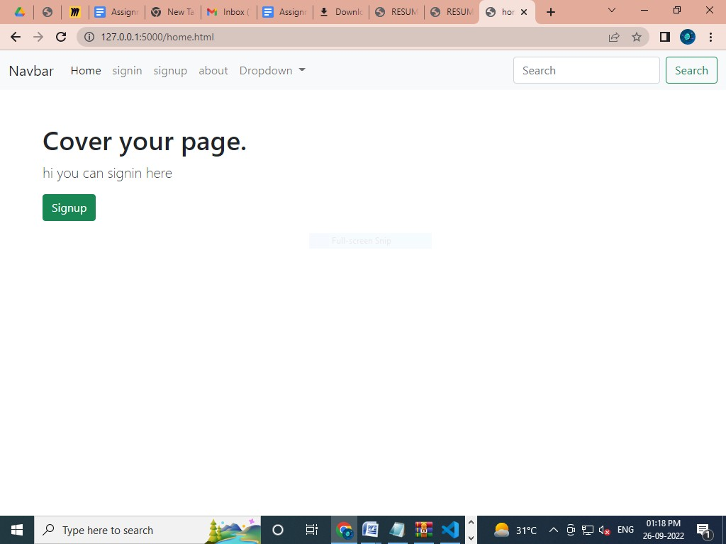

**Signin page:**

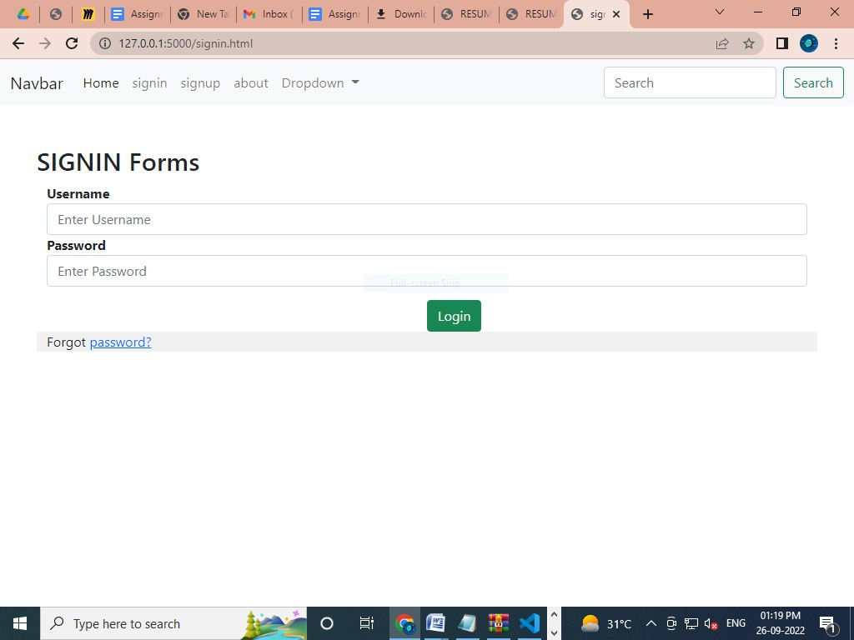

**signup page:**

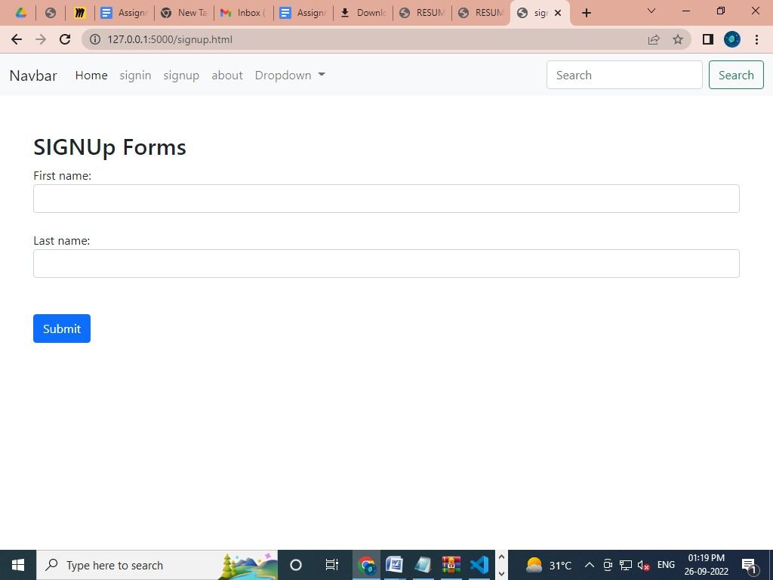

About page:

